Pulse Volume/Pulse Duration*PULSE(Inflow Time,Pulse Duration)

Exercise 2 Fishery model

• Define/articulate the Issue/Problem (focus the effort)

* explicit purpose – This model is designed to illustrate the parallel consequences to the chronic overtaxing of the local fish population. I would like to explore the benefits and detriments to alternate policies.
* Reference Behavior Pattern (RBP) – If the fish population is left to its own devices, the population should find an equilibrium dependent primarily on the population density. As a note, in this model, we are presuming that all fish reach adulthood, there are unlimited food resources, and unlimited waste removal. The parallel aging progression is representing the introduction, aging and retiring of vessels dependent solely on a 20-year delay. We are presuming that there are no other expenditures toward any vessel during it’s lifespan, and that all reach retirement at 20 years without exception. This model is, however, exploring the interrelationship of a predator / prey model with an added economy. On the predator side, we have a payback period incentive to
* Questions

1. What feedback loops are present in your model?

There are 12 feedback loops in this model. They are: Maturing, Per Capita Birth, Life, Mortality Impact, Breeding, Catch Impact, Death, Catching, Catch Effectiveness, Population Driven Mortality, Vessels Retiring and Vessels Adding loops.

1a) How do they influence its behavior?

* + **Maturing Loop** – This represents Juvenile Fish maturing to Adult Fish to become breeding candidates.
  + **Per Capita Birth Loop**– This influences the number of births with respect to Fish Population Density. The control it influences is the Current Birth Fraction.
  + **Life Loop**– This is the life cycle of a fish; birth, maturing, breeding, but does not include dying.
  + **Mortality Impact Loop** – This influences the number of breeding Adult Fish and subsequently, Fish Population Density. It is the impact that is created by the death of Adult Fish.
  + **Breeding Loop** – This is the population feeder source. The sensitivity is in the Current Birthing Fraction
  + **Catch Impact Loop** – The more Adult Fish who are caught, the less are breeding, and the lower the population density.
  + **Death Loop** – This is Adult Fish dying. It removes stock from the Adult Fish and lessens the Fish Population Density.
  + **Catching Loop** – This is the link between the Fish progression and the Vessels progression. It is representing the catching of Adult Fish by Vessels.
  + **Catch Effectiveness Loop** – The higher the density of fish in a given area, the higher the probability of a Vessel catching fish. This loop modifies the amount of catch per vessel with respect to Fish Population Density.
  + **Population Driven Mortality Loop** – When the population density gets too high, there are more deaths. This loop represents that feedback system.
  + **Vessels Retiring Loop** – As vessels age, they lose functionality until they cross a threshold of usability. This reduces the stock of Vessels over time once they cross that threshold.
  + **Vessels Adding Loop** – This adds vessels as opportunity allows, instead of on the basis of necessity.

1. What happens with different INITIAL VALUES for fish population and/or fleet size?

When the initial number of fishing vessels was changed to 50, the number of fish began lower but stabilized at the same point as with 20 initial vessels. When the fish population was increased to 5E6, there was a disturbance early in the model, but it stabilized back out at the same point of equilibrium.

2a) What happens when you change various parameters such as revenue-per-fish, K, Maximum yield, etc.?

Changing Revenue Per Fish to $3 made Adding Vessels shoot up to 0.00041 from 0.00028. Dropping K to 5E6 dropped the number of fish dramatically, of course. Changing K to 1E9 gave a result of more fish.

1. How would you model a major subsidy that cuts the effective cost of vessels in half after, say, five years?

I could add a PULSE TRAIN to interject with half the value of a vessel to vessel cost to initiate after 5 years.

1. On top of this, what if K were to degrade linearly over 50 year run to half its value? How would you model this.

K(t)=K0 * (1- .01*t)

**Reference Behavior Pattern is the actual behavior of the real world**.  It could be described qualitatively as prose, or quantitatively in tabular or graphical format.

* + select one or two key measureable aspects of the real world that summarize or encapsulate the behavior of interest
  + document the values over time for these key aspects
    - Fish Population Density
      * t0 = 3E6
      * Equilibrium = 1.3E5
    - Juveniles
      * t0 = 1.5e+006
      * Equilibrium = 8E6

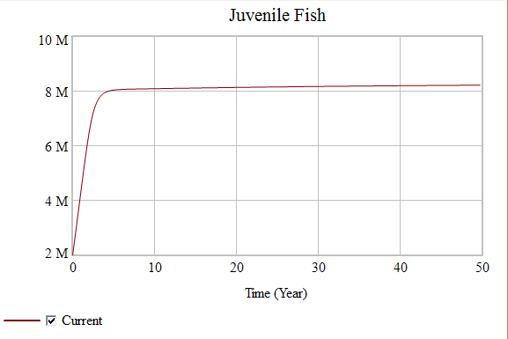

* + - Adults
      * t0 = 1.5e+006
      * Equilibrium = 5.5E5

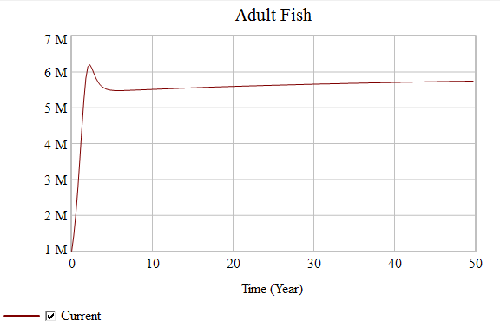

* + - Revenue per Vessel = alternates each year $102K & $180K

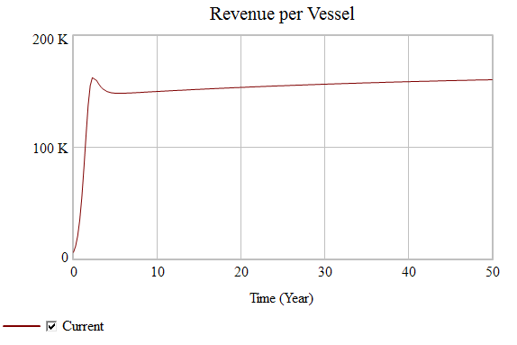

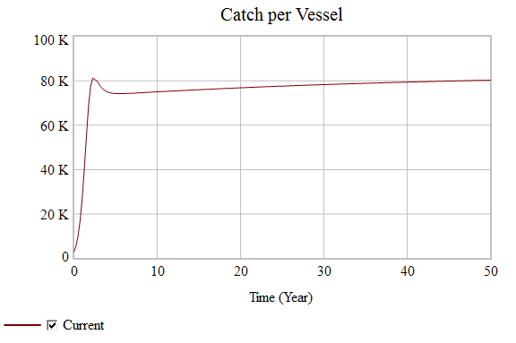

* + should capture the essential qualitative behavior
  + growth, oscillation, growth followed by stagnation, overshoot & collapse, perpetual delays, etc.

• Formulate Model

* Develop & Represent Dynamic Hypothesis[es]
  + dynamic organizing principle
  + map the hypotheses
* Think operationally: make the map simulatable
  + id. storages
    - Juvenile fish
    - Adult Fish
    - Fishing Vessels
  + characterize flows
    - Fish - Birth through Death
      * This is the life cycle of fish within a population. They are born as juvenile fish and mature over time to Adult fish, whereupon they become breeding candidates. Not all adults breed at all times, so we have set that to about ½ of the Adults successfully procreate in a breeding season.
    - Vessel - Purchase through Retirement
      * This is the “life cycle” of a Trawling Vessel. The bank loans money with a payback period attached, and the vessel is purchased and set to work. The Vessel will last about 20 years and be retired. I am not tracking every vessel, I am simply retiring 1/20 of the vessels per year. That is to say: Fishing Vessels/20.
  + id. feedback loops
    - **Maturing Cycle**

Juvenile Fish 🡪 Maturing

* + - **Per Capita Birthing Cycle**

Juvenile Fish 🡪 Fish Population Density 🡪 Current Birth Fraction 🡪 Birthing 🡪

* + - **Life Cycle**

Juvenile Fish 🡪 Maturing 🡪 Adult Fish 🡪 Birthing 🡪

* + - **Mortality Impact Cycle**

Juvenile Fish 🡪 Fish Population Density 🡪 Current Death Fraction 🡪 Dying 🡪 Adult Fish 🡪 Birthing 🡪

* + - **Breeding Cycle**

Juvenile Fish 🡪 Maturing 🡪 Adult Fish 🡪 Fish Population Density 🡪 Current Birth Fraction 🡪 Birthing 🡪

* + - **Catch Impact Cycle**

Juvenile Fish 🡪 Fish Population Density 🡪 Catch Multiplier 🡪 Catch 🡪 Catching Fish 🡪 Adult Fish 🡪 Birthing 🡪

* + - **Death Cycle**

Adult Fish 🡪 Dying

* + - **Catching Cycle**

Adult Fish 🡪 Catch 🡪 Catching Fish

* + - **Catch Effectiveness Cycle**

Adult Fish 🡪 Fish Population Density 🡪 Catch Multiplier 🡪 Catch 🡪 Catching Fish 🡪

* + - **Population Density Driven Mortality Cycle**

Fish Population Density 🡪 Current Death Fraction 🡪 Dying 🡪 Adult Fish 🡪

* + - **Vessels Retiring Cycle**

Fishing Vessels 🡪 Retiring Vessels 🡪

* + - **Vessels Adding Cycle**

Fishing Vessels 🡪 Catch 🡪 Catch per Vessel 🡪 Revenue per Vessel 🡪 Payback Period 🡪 Adding Vessels 🡪

**Model of a Fishery**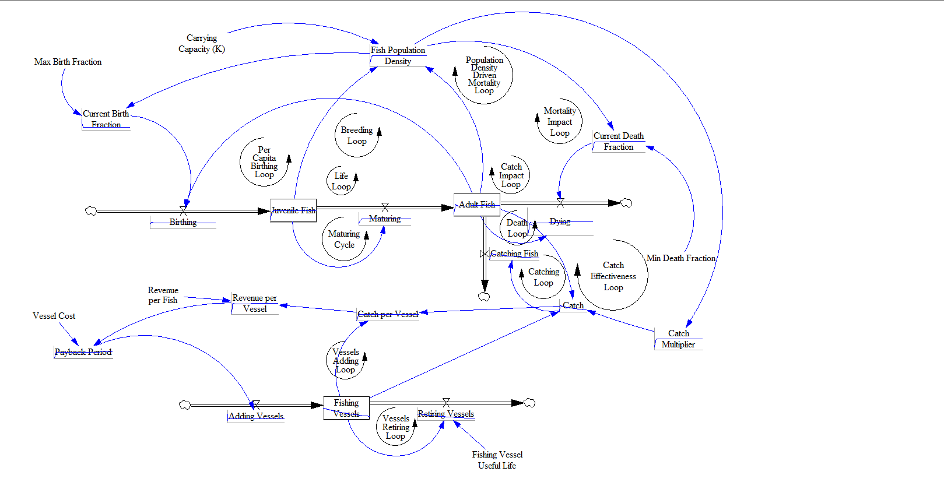

* + specification and calibration (determine equations & parameters)
    - **Global Variables**
    - Total Simulation Time = 50 years
    - Step Time = 1 year
    - **Fish**
    - Carrying Capacity, K=1E7
    - Initial fish population, N(t=0) = ~ 3E6 - 5E6
    - Initial Juveniles = 1.5E6
    - Initial Adults = 1.5E6
    - Maximum Birth Rate = ~ 1 - 1.2 (in other words, no more than 1 – 1.2% of the population reproduces in any time period)
    - Max. Birthing Faction = 0.01 – 0.012
    - Minimum Death Rate = 0.1 (at least 10% of the fish population dies in any time period)
    - Fish Population Density: (Adult Fish+Juvenile Fish)/"Carrying Capacity (K)"
    - Current Birthing Fraction = Max Birth Fraction/Fish Population Density
    - Birthing = (Adult Fish*Max Birth Fraction)
    - Juvenile Fish = Birthing-Maturing
    - Maturing = Juvenile Fish/2
    - Time for fish to mature: 2 years (if you use two storages)
    - Adult Fish = Adult Fish + Maturing - Catching Fish - Dying
    - Catch = Adult Fish*Fishing Vessels*Catch Multiplier
    - Dying = Adult Fish*Current Death Fraction
    - Min Death Fraction = 0.1
    - Current Death Fraction = Min Death Fraction*EXP(Fish Population Density*2)
    - **Vessels**
    - Payback Period = Revenue per Vessel-(Vessel Cost/10)
    - Initial number of Vessels: 20-50
    - Vessels (Current number of active Vessels) = Adding Vessels-Retiring Vessels
    - Cost of new vessel: ~$100,000 - $200,000
    - Vessel useful life = 20 years
    - Retiring Vessels = Fishing Vessels/Fishing Vessel Useful Life
    - Maturing = Juvenile Fish/2
    - Dying = Adult Fish*Current Death Fraction
    - Catching Fish = Catch
    - Adding Vessel = 10/Payback Period
    - Retiring Vessels = Fishing Vessels/Fishing Vessel Useful Life
    - Catch Multiplier = Fish Population Density*0.01

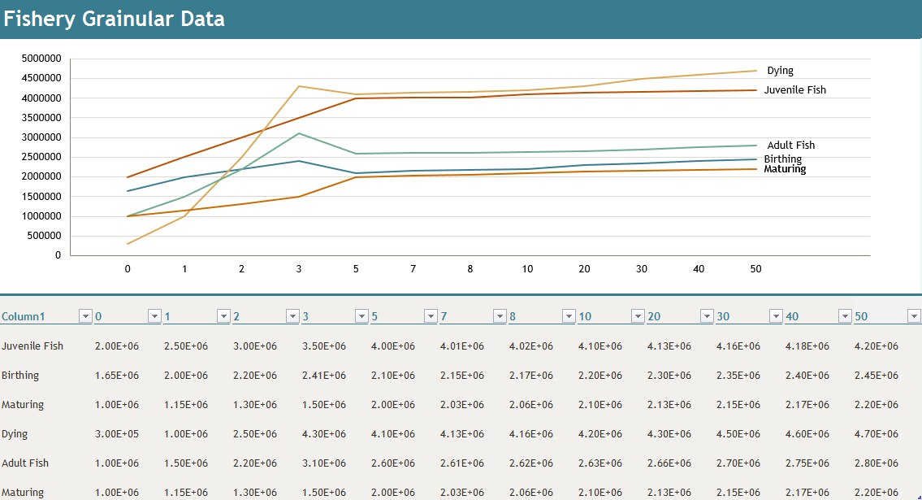

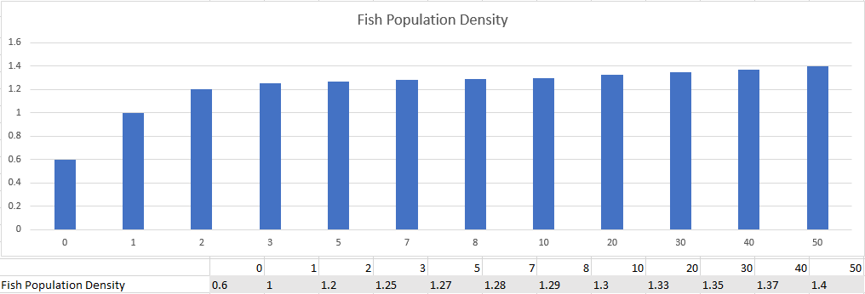

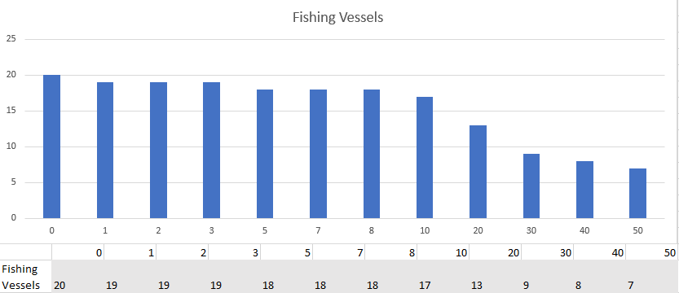

• Test Model

* + mechanical mistake tests
    - I have tested and revised almost all equations. They should now be functioning correctly together.
  + robustness tests
    - I have increased the initial fish population to equal 3E6, and the same behavior was observed
    - I have decreased the initial fish population to equal 1000, and the same behavior was observed
  + diagnosing surprise behavior
    - I am not seeing any behavior which I find surprising.
* Verification
  + understanding model behavior/dynamics
    - We are seeing a classic Predator / Prey collapse, recover, overshoot, collapse oscillation within both populations.
  + hypothesis tests
    - I have run the model and my hypothesis seems to hold true.
  + exploring dynamic behavior
* Validation
  + challenge the boundaries (extensive & intensive)
    - I have changed the initial values of Juveniles and Adults, as well as the Maturation rate.
      * Changing Adults to 1E6 and Juveniles to 2E6 gave similar results. The equilibrium point remained the same.
      * Changing Adults to 2E6 and juveniles to 1E6 gave similar results, the equilibrium point remained the same.
      * Changing Maturation Rate to Juvenile Fish/3 gave me an equilibrium point that was higher in Juveniles and lower in Adults, but that was expected. It also stopped the minor oscillation.

• Model Application & Transfer

* Design and Evaluate Policies
  + policy/theory
    - This model represents the Year-by-year growth and population of a coastal fishing fleet and the local fish stock. Using this model, we can experiment with allowing different maturation rates and starting quantities of Adult and Juvenile fish, as well as Vessels and Payback Period. We can find the most sensitive variables and the optimal initial values for targeting population density / environmental capacity / fishing revenue stability.
    - We will experiment with differing ratios of initial Adult / initial Juvenile Fish, as well as changing the initial total population.
    - We will experiment with changing the monthly volume of Juveniles allowed to reach maturity.
    - We are unrealistically assuming that no Juveniles die or get caught.
  + Sensitivity
    - The maturation rate and Fish Population Density seem to be the variables most sensitive to change.
  + scenarios
    - We are studying a stocked and maintained fishery of some type.
* Make Learning Available (communicate)
  + develop a drama
    - Beginning at year 5, the habitat becomes progressively more damaged over 50 years. The citizenry isn’t aware of the damage until half of the Carrying Capacity is decimated. The fall in fish supplies causes the price per fish to rise to $4 per fish. At the same time, the cost of new vessels halves as well.
    - My hypothesis is that the number of Fish will decline, but Revenue per Vessel will remain the same because as the Fish Population Density declines, so does the Fishing Effectiveness.
    - That is indeed what we see:

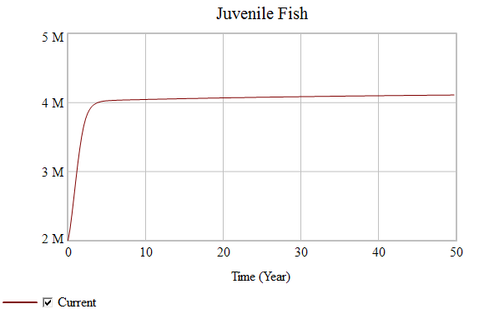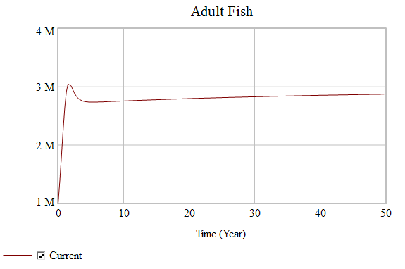

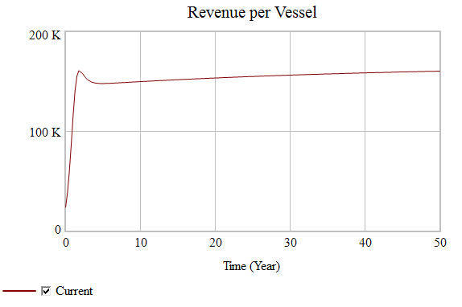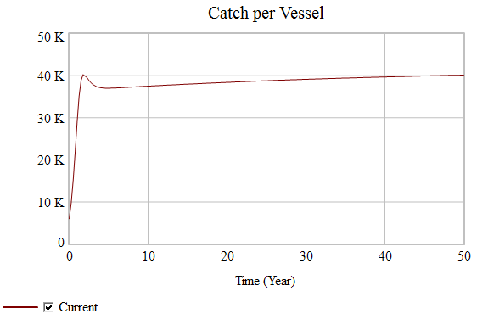

* + design a learning progression
    - We will experiment with differing ratios of initial Adult / initial Juvenile Fish, as well as changing the initial total population.
    - We will experiment with changing the monthly volume of Juveniles allowed to reach maturity.
    - We will experiment with Payback Period.
    - Success will be defined by the identification of emergent patterns and properties, and the discovery of individual variable sensitivities and response patterns to variable changes.
  + implement a learning progression
    - To begin, the model will be created and tested.
    - Second, the baseline values will be entered and recorded.
    - The results will now be validated by the challenging of all known and/or expected limitations. In this case; we will expand the time horizon to 100 months, we will stock the fishery to and over carrying capacity, and we will minimize and maximize the maturation rate to find breaking points.
    - Finally, the variables will be methodically altered following tolerances and results recorded to establish patterns and/or properties as well as any emergent patterns/properties.
* Conclusion
  + This model does allow for experimentation with policies.
  + The fish populace is tolerant to a large amount of fishing, but market forces coupling with population densities will force the number of vessels down
  + This means that changing the number of vessels will not have a significant effect on the revenue of the full fleet.
* What I learned
  + I have learned how to create a model in Vensim, and to test the model for correctness, robustness of calculations, and how to locate system sensitivities.
  + I have learned how to tune a model.
  + I have learned that decreasing the Time Step will smooth out an artifactual oscillation.
  + I have learned q bit about translating real world observations to mathematical expressions.
  + I have learned that fish populations are a lot more resilient than I had previously though.
  + Playing with every variable excepting “Carrying Capacity”, I found that there was no way to impact the number of fish enough to cause a population collapse.
* Potential Improvements
  + The majority of the improvements to this model have to do with the modeler needing experience, not a deficiency in this model. It is not a perfect representation of reality, but it is a perfect representation for the purpose that it serves. It has not been over-complicated or over-simplified owing to the fact that its intended use is practice and process study/experimentation.